The citric acid cycle, also known as the tricarboxylic acid cycle (TCA cycle) or the
A. Respiratory Chain
B. Electron Transport Chain
C. Krebs Cycle
D. None of these
ANSWER: C
What is the final product of the Krebs cycle?
A. Malate
B. Succinate
C. Oxaloacetate
D. Fumarate
ANSWER: C
Each Krebs’s cycle forms how many molecules of NADH?
A. 3
B. 2
C. 4
D. 1
ANSWER: A
The hydrogen and electrons which are released from succinate are taken up by:
A. FAD
B. PAD$H_{2}$
C. NAD
D. NAD
ANSWER: A
Which molecule passes the mitochondrial membrane to begin the Krebs cycle?
A. Pyruvate
B. Glucose
C. NADH
D. Acetyl CoA
ANSWER: D
A single molecule of glucose generates _________ molecules of acetyl CoA, which enters the Krebs cycle.
A. 4
B. 3
C. 2
D. 1
ANSWER: C
___________ accepts hydrogen from malate
A. FAD
B. NAD
C. NADP
D. FMN
ANSWER: B
Which of the following is not formed during the Krebs cycle?
A. Lactate
B. Isocitrate
C. Succinate
D. Both (a) and (b)
ANSWER: A
FAD is reduced in which of the reaction of Kreb’s cycle?
A. Isocitrate to oxaloacetate
B. Succinyl CoA to Succinate
C. Fumarate to malate
D. Succinate to fumarate
ANSWER: D
What is the Product formed by malic acid dehydrogenase is?
A. Fumaric acid
B. Oxaloacetic acid
C. Succinic acid
D. Citric acid
ANSWER: B
What is the other name of Krebs Cycle
A. EMP pathway
B. Citric acid Cycle
C. Glyoxylate Cycle
D. Calvin Cycle
ANSWER: B
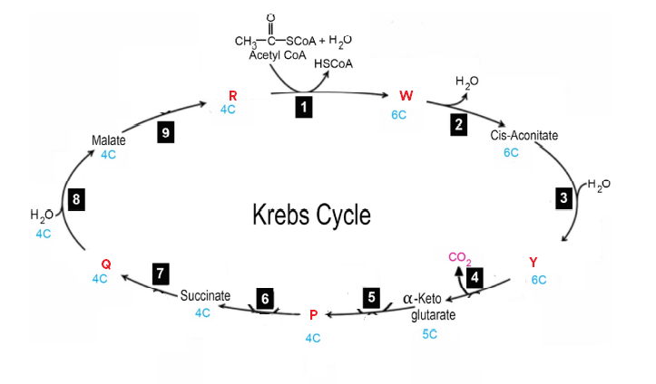
What does W represent in the given diagram?
A. Citrate
B. Isocitrate
C. Succinyl CoA
D. Fumarate
ANSWER: A

What does Y represent in the given diagram?
A. Citrate
B. Isocitrate
C. Succinyl CoA
D. Fumarate
ANSWER: B

What does P represent in the given diagram?
A. Citrate
B. Isocitrate
C. Succinyl CoA
D. Fumarate
ANSWER: C

What does Q represent in the given diagram?
A. Citrate
B. Oxaloacetate
C. Succinyl CoA
D. Fumarate
ANSWER: D

What does R represent in the given diagram?
A. Citrate
B. Oxaloacetate
C. Succinyl CoA
D. Fumarate
ANSWER: B

This is the diagrammatic representation of:
A. Glycolysis
B. Citric Acid (Krebs) Cycle
C. Electron Transport Chain
D. Chemiosmosis
ANSWER: B

